Amelia-Rae Flynn’s work 4th February
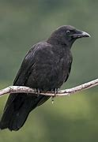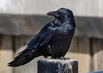

The dark scary shadow followed the little girl and its shiny coat glimmered in the light as it watched her. The little girl soon found out it was following her and she began to run as she was very scared, she ran until she felt she was safe.

The ostrich is fast, the horse is faster. The cheetah is the fastest

Fast is the root word
Faster and fastest are the suffix
What happens to the root word when we add ER and EST
Strange.... Stranger and strangest

ER and Est are types of suffixes. When we add ER and EST to the end of a root word it becomes an adjective

Rich becomes Richer and Richest
Late becomes Later and latest
Simple becomes Simpler and simplest
Grate becomes Grater and Greatest
Wide becomes Wider and Widest
When adding suffixes

COLOUR BLOCKING
Largest
I would block L on its own then AR then G then EST

SPELLING TEST
- Sweeter
- Sweetest
- Weaker
- Weakest
- Stronger
- Strongest
- Larger
- Largest
- Safer
- Safest

